

M.Sc. Computer Science and Engineering

Software Engineering 2 Project

**CLup - Customers Line-Up**

**Design Document**

Leoni Luca, Locarno Silvia, Minotti Luca

10th January 2021

Version 1.0

GitHub Repository: https://github.com/lucagrammer/LeoniLocarnoMinotti

**Contents**

1 Introduction 3

1.1 Purpose 3

1.2 Scope 3

1.3 Definitions, Acronyms, Abbreviations 3

1.3.1 Definitions 3

1.3.2 Acronyms 4

1.3.3 Abbreviations 4

1.1 Revision History 4

1.2 Reference Documents 4

1.5 Document Structure 5

2 Architectural Design 6

2.1 Overview 6

2.2 Component View 8

2.3 Deployment View 8

2.4 Runtime View 8

2.5 Component interfaces 8

2.6 Selected Architectural Styles and Patterns 8

2.7 Other design decisions 8

2.7.3 Relational Database 8

3 User Interface Design 9

3.1 UX Diagrams 9

3.2 User Interface Mockups 9

4 Requirements Traceability 10

5 Implementation, Integration and Test Plan 11

5.1 Development Process 11

5.2 Implementation 11

5.2.1 Implementation Plan 11

5.2.2 Implementation Choices 11

5.3 Integration 11

5.3.1 Entry Criteria 11

5.3.2 Elements to be integrated 11

5.3.3 Integration Sequence 11

5.4 Test Plan 11

6 Effort Spent 12

6.1 Leoni Luca 12

6.2 Locarno Silvia 12

6.3 Minotti Luca 12

7 References 13

**Chapter 1**

# 1 Introduction

## Purpose

This document constitutes the Design Document (DD). It provides a more technical overview of the Requirement Analysis and Specification Document (RASD) of the system-to-be, describing the main architectural components, their communication interfaces and their interactions.

It will also present the implementation, integration and testing plan. This type of document is mainly addressed to developers since it provides a guide during the development process through an accurate vision of all parts of the software-to-be.

## Scope

As explained in the RASD, CLup aims to manage the queues to access stores in the Coronavirus era in a simple but effective way. Avoiding dangerous gatherings and unnecessary waste of time, CLup allows you to queue at a store directly from the application and receive a notification when it is time to reach the store, taking into account the time required to get to the shop using the indicated means of transport. Of course, fall-back options are available for people who don't have access to the required technology.

Moreover, the CLup Application also allows you to book a visit to a store in advance by indicating the date, time and product categories you are interested in. In addition, in case the desired slot is full, CLup provides useful suggestions for other slots available at the selected store or similar less crowded stores at the indicated date and time.

Furthermore, CLup can periodically notify you of the availability of slots in the day/time range in which you usually shop.

On the other hand, supermarket managers can easily keep access data under control and effortlessly ensure compliance with safety regulations.

## 1.3 Definitions, Acronyms, Abbreviations

### 1.3.1 Definitions

* **CLup System (or “The System”)**: refers to the whole system to be developed.
* **CLup Services (or “Services”)**: refers to the functionalities offered by the CLup System, such as the queue management mechanism and the booking service.
* **CLup Application (or “The Application”)**: refers to the application that makes CLup Services available everywhere.
* **QR** **Code**: quick response code, a type of matrix barcode.
* **Reservation ID**: a code that unequivocally represents either a position in the queue or a slot reservation.
* **Physical Ticket Dispenser**: a computer connected to the CLup System that distributes paper tickets. It acts as a proxy for Guests.
* **Guest**: a person who has not access to the CLup Application but still uses the CLup Service to access stores through Physical Ticket Dispensers.
* **Customer**: a person that uses the CLup Application and its services to access stores and book visits.
* **Client (or Store Client)**: either a Customer or a Guest.

### 1.3.2 Acronyms

* **RASD**: Requirement Analysis and Specification Document.
* **DD**: Design Document
* **UML**: Unified Modelling Language.
* **API**: Application Programming Interface.
* **PTD**: Physical Ticket Dispenser.
* **GPS**: Global Positioning System.
* **API**: Application Programming Interface.
* **ETA**: Estimated Time of Arrival

### 1.3.3 Abbreviations

* **[R.i]**: i-th requirement.

## Revision History

|  |  |  |  |
| --- | --- | --- | --- |
| **Version** | **Date** | **Authors** | **Summary** |
| 1.0 | --/--/2020 | Leoni Luca  Locarno Silvia  Minotti Luca | First release |

## Reference Documents

* Specification document: Project Assignment A.Y. 2020-2021.pdf
* RASD of CLup
* Software Engineering 2 course slides
* Previous project examples:
* Specification document: Project Assignment A.Y. 2019-2020.pdf
* DD to be analyzed.pdf
* IEEE Standard on Requirement Engineering (ISO/IEC/IEEE 29148)

## 1.5 Document Structure

This document is structured as follows:

1. ***Introduction*** - A general introduction of the system-to-be. It aims at giving general, but exhaustive, information about what this document is going to explain.
2. ***Architectural Design -*** An overview of the high-level components and their interactions, with a focus on both static and dynamic view, helped by diagrams.
3. ***User Interface Design -*** A representation of how the User Interface will look like.
4. ***Requirements Traceability* *-*** An explanation about how the requirements defined in the RASD map to the design elements defined in this document.
5. ***Implementation, Integration and Test Plan* *-*** Identification of the order in which the sub-components of the system should be implemented, integrated and tested.
6. ***Effort spent*** - Effort spent by all team members shown as the list of all the activities done during the realization of this document.
7. ***References*** - References to documents that this project was developed upon.

**Chapter 2**

# Architectural Design

## Overview

The figure below represents a high-level description of the main components which constitute the System. They are organized in a 4-tier architecture thus facilitating maintainability and scalability. In particular, the *Web Server* and the *Application Server* have been separated mainly for security reasons. Further details about the architectural choices can be found in sections 2.6 and 2.7.

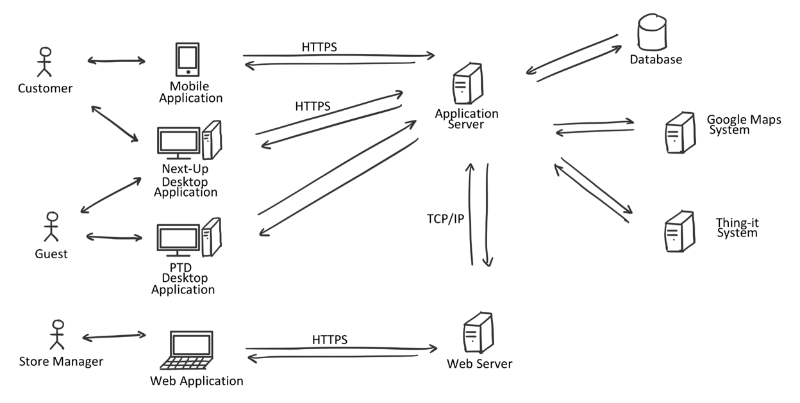

Figure 1: Overall architecture of the system

The main components of the Systems are the following:

* **Web Application**

A web application accessible through the Store Manager’s browser that allows him to access CLup Services. The web app will work with the most modern internet browsers, which communicate with the System by sending requests to the *Web Server*.

* **Customer Mobile Application**

An application installed on the Customer’s smartphone that allows him to use CLup Services anywhere. It communicates with the System forwarding every request to the *Application Server*. The mobile application will be available for both iOS and Android devices.

* **PTD Desktop Application**

An application installed on a touchscreen device located near the entrance to each store that allows Guests to use the “Line Up” Service. It communicates with the System forwarding every request to the *Application Server*. This application will be available for both macOS and Windows devices.

* **Next Up Desktop Application**

An application installed on a device located near the entrances of each store that allows both Customer and Guests to know which Reservation IDs are allowed to access the store. It communicates with the System through the *Application Server*. This application will be available for both macOS and Windows.

* **Web Server**

It is the back-end component of the *Web Application* that communicates with the Store Manager’s browser on one hand and with the components of the *Application Server* on the other (i.e. the Business logic tier).

* **Application Server**

It is the main back-end component of the System on which the business logic of the application takes place: it elaborates the requests coming from the end-user applications, it interacts with the data layer and the web layer and it communicates with the various external systems.

* **Database**

It is the component responsible for data storage. It can only be accessed by the Application Server.

* **External Systems**

These are systems that provide functionalities that are not internally developed. *External Systems* interact mainly with the *Application Server*.

* **Google Maps System**: this system is responsible for providing the Map Services necessary for computing the ETA and supporting the identification of stores close to a customer.
* **Thing-it System**: this Smart-Office System allows CLup to remotely control the sliding doors of the store and communicate with the QR code readers.
* **Ticket Printing System**: this system is responsible for printing paper tickets. It’s directly connected to the device running the *PTD Desktop Application.*

## Component View

## 2.3 Deployment View

## 2.4 Runtime View

## 2.5 Component interfaces

## 2.6 Selected Architectural Styles and Patterns

## 2.7 Other design decisions

### 2.7.3 Relational Database

**Chapter 3**

# User Interface Design

## 3.1 UX Diagrams

## 3.2 User Interface Mockups

**Chapter 4**

# Requirements Traceability

**Chapter 5**

# Implementation, Integration and Test Plan

## 5.1 Development Process

## 5.2 Implementation

### 5.2.1 Implementation Plan

### 5.2.2 Implementation Choices

## 5.3 Integration

### 5.3.1 Entry Criteria

### 5.3.2 Elements to be integrated

### 5.3.3 Integration Sequence

## 5.4 Test Plan

**Chapter 6**

# Effort Spent

The following tables summarize the effort spent by each member of the team to create the DD document.

## 6.1 Leoni Luca

|  |  |
| --- | --- |
| **Description of the task** | **Hours** |
|  |  |
|  |  |
|  |  |

## 6.2 Locarno Silvia

|  |  |
| --- | --- |
| **Description of the task** | **Hours** |
|  |  |

## 6.3 Minotti Luca

|  |  |
| --- | --- |
| **Description of the task** | **Hours** |
|  |  |

**Chapter 7**

# 7 References

* E. Di Nitto. Lecture Slides. Politecnico di Milano.
* E. Di Nitto. Project Assignment AY 2020-2021. Politecnico di Milano.
* ISO/IEC/IEEE 29148:2011. Standard on requirement engineering. https://standards.ieee.org/standard/29148-2011.html.